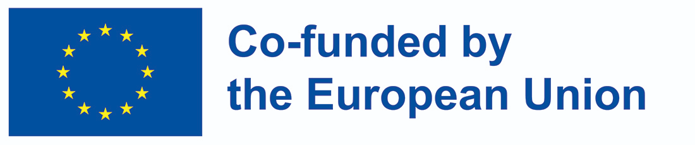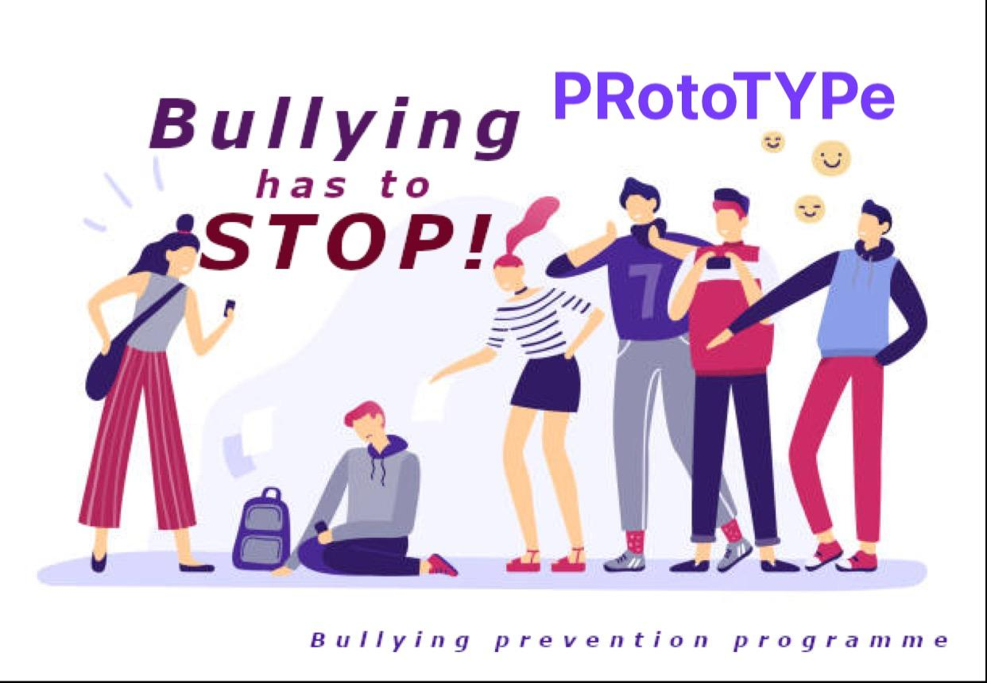

**PRotoTYPe – ​ MINUTES OF THE MEETING**

**The title of the project: : Preventing School-Based Bullying by Creating Early Prevention Programme**

**Project number:** **2021-1-PL01-KA220-SCH-000032708​**

​**Acronym: PRotoTYPe**

**2nd Transnational Project Meeting**

**Venue:** Lusófona University, Lisbon, Portugal, Campo Grande, 376

**Subject: ​Prototype Second Transnational Project Meeting**

**Location:** ​Lusófona University, Lisbon, Portugal

**Date & Time:​** 25.10.22 - 26.10.22

**Hosts:** Slavisa Tomic - Lusófona University

João Pedro Carvalho- Lusófona University

**Attendees:** 12

-online participation 1

**DAY 1: 25th October, 2022**

**I. Welcome Session**

The PRotoTYPe Meeting started at 9:30 with a welcome by the hosts and the presentation of the agenda for the project working days.

**II. Presentation of the risk analysis by Frank Hiddink**

Frank Hiddink presented the Risk Analysis via a video conference and explained the issues connected with the implementation of the first project result.

The Partners wanted the analysis to be presented by each country separately, so it is a clear relation to the country level data and with the consideration on how survey participants have answered the questionnaire in each country and organisation. As the first outcomes appeared, partners agreed on the inclusion of the results on a school level. The participants discussed the final results of the survey.

**III. Factor and Need Analysis tasks- by COFAC**

The project team took part in the discussion about questions for factor analysis. It was also a debate on the types of the questions which should be presented in the survey.

Uludag University’s professor Rucan, who joined our meeting via Teams’ conference and we had a discussion about the factor analysis. it was agreed that The Turkish and Portuguese partners would consult the survey questions with the professors’ support and the final version of the questionnaire would be presented to all partners.The next point of the meeting was a lunch break in a local cafeteria at Lusofona University.

**IV. Preparatory tasks before the next transnational meeting**: discussion on the preparatory tasks before the next transnational meeting: tasks according to the deadlines.

**V. Evaluation of the project tasks up to now**

The Project Management Board presented a short outline of the project activities done so far and emphasised the quality of the final project outcomes and the project timeline.

Discussions about the Games as one of the final outcomes.

The project team started the brainstorm activity before the Computer Game activity procedure, as Olemisen Balanssia ry is in charge of creating the game and the fact that salaries in this area are very high. We discussed how this game should work especially with the game being targeted at 15–18-year-old teenagers so it needs to be suitable for this age group.

There was a discussion on the fact that a player could chose to be a Buller, a Victim or a Bystander and there could be the multiple readymade choices for answers and we should collect all different answers and paths the person is selecting and then we should analyse different scenarios how persons could behave in a particular situation. It was the brainstorm activity with the general ideas to follow and it was decided that all partners need to attend developing the game storyboards and which kind of selection will lead to the next point of the selections. The development needs to be done in English level, but local versions need to be translated into their own language.

**VI. Closing the meeting**

The meeting finished at 17:00

**DAY 2: 26th October, 2022**

**I. Dissemination of the project.**

The second day of the project meeting started at 9:30.

The Dissemination Procedure was discussed and an Evidence Excel Sheet was introduced to all partners. The Evidence Excel Sheet is the project document in which everybody should enter their own dissemination actions and related links to the evidence i.e Facebook, Instagram or Twitter posts and local media newspapers etc. OMEM presented the dissemination procedures and some of the main points are as follows:

-There is no logo form of Franks’ organisation.

-The Project's logo is not clear enough.

-The Portuguese partners promised to enhance the logo and sent corresponding RGB codes for colours, so we can use the same colour everywhere we need.

-The Partners suggested that we should use the same hashtags for the project:

#stopbullying

#preventionprogram

#kindness

#bullyinghastostop

#yestopolyteness

#gamification

- Each dissemination action, old and new ones must be maintained in this Dissemination table before 30.11.22.

-Monitoring and evaluation plan was discussed and it will be done by Frank. The Portuguese partners planned to join a suitable international conference and publish our results there.

-Each partner will invite their contacts to join Prototype groups.

-The Coordinator is supposed to send the links for Prototype Facebook and Instagram.

-Slavisa will send questionnaires to all participants.

**II.Social media and the project web site for the PRotoTYPe** - done by the project coordinator.

According to the Project Agenda, Filiz and Agnes presented the prototype website and the social media project content. Each partner is obliged to upload a link to the Prototype web page for their own organisations’ web pages.

It was reminded that the eTwinning link needs to be added to the Prototype web pages.

The coordinator will add the sample of time sheets to the Google Drive that partners need to use. The social media cover for Prototype was introduced and the links to the fb group and Instagram were uploaded as a reminder to the project WhatsApp group.

**III. The upcoming transnational meetings schedule**

At the end of the meeting, we discussed the dates of TPMs in Turkey and Finland. The final decision was that the dates for TPMs are as follows:

**Bursa (Turkey)- 19th -20th September, 2023** and **TPM in Finland: 21st- 22nd February, 2024** as a Cruise ship between Turku and Stockholm. Responsible partners will organize the meetings and provide infopacks.

**IV. Evaluation and conclusions:**

The project partners were asked to fill in the evaluation questionnaires prepared by the hosts. After the survey session, it was a general discussion in which each partner could express the opinions on the project involvement and tasks’ implementation procedures as well as general views on the project team cooperation.

Conclusions: the project activities should be discussed in our group and during online conferences, the project schedule is rearranged according to the suggestions made by the Polish National Agency as the summary of the project application, all the important data will be presented in our project team, the Management Board will guide the project implementation.

**V. Assessment and certificates distribution**

The certificates were distributed by the Portugese team.

*This project has been funded with support from the European Commission. This publication reflects the views only of the author, and the Commission cannot be held responsible for any use which may be made of the information contained therein.*